**New EQ File Creation/Release Process**

8/7/15

Acoustics Engineers

1. Create EQ file and save with descriptive name on S-Drive.
2. Create temporary vbf file.  
   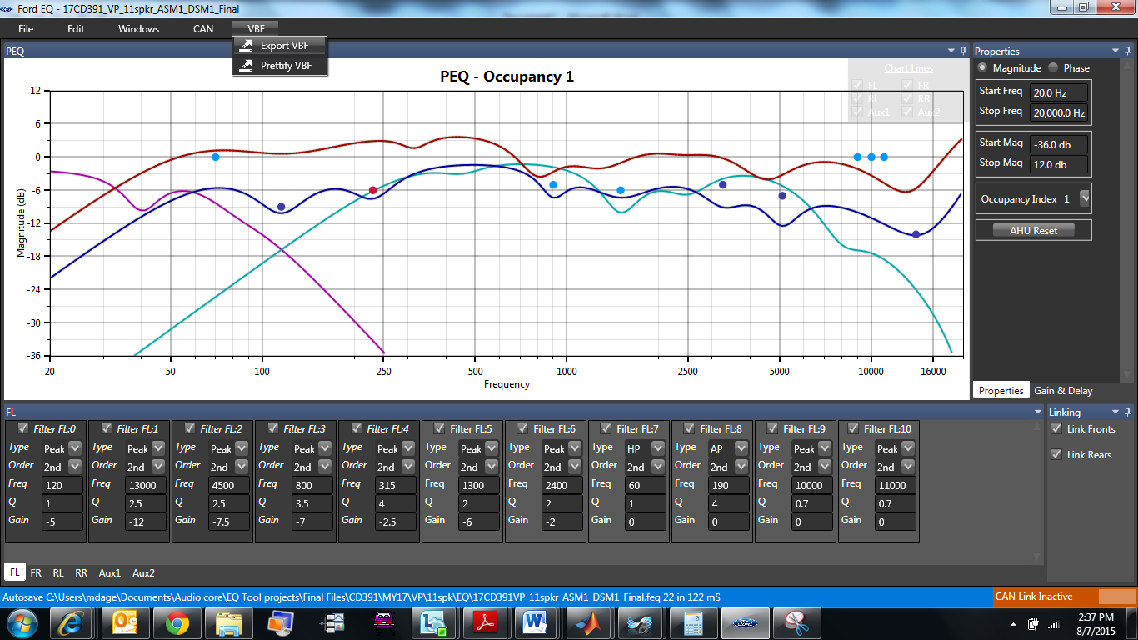

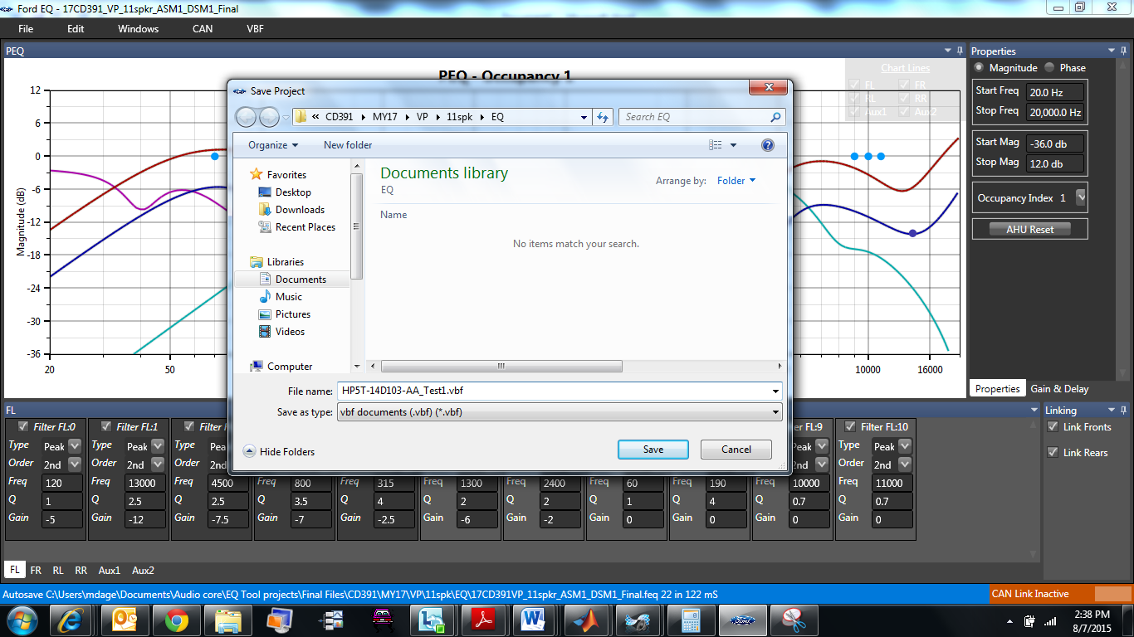

1. Request secondary bootloader for AHU from AHU D&R.
2. Read F10A DID to see what current EQ file is in radio (for post-VP builds).

Download from cross-supplier core sharepoint in appropriate folder  
File structure is Program -> MY - > Milestone - > Speaker system - > EQ+Chimes Merged vbf

1. Flash temporary vbf into AHU using DET tool and validate that the car measures the same as it did while live tuning. SWDL file order is secondary bootloader and EQ vbf only.   
   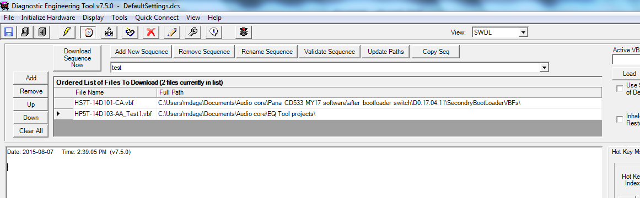
2. Flash EQ+Chimes merged vbf back into AHU using DET tool. If it’s a VP vehicle, flash flat EQ+Chimes merged vbf.
3. Upload to cross-supplier core sharepoint in appropriate folder

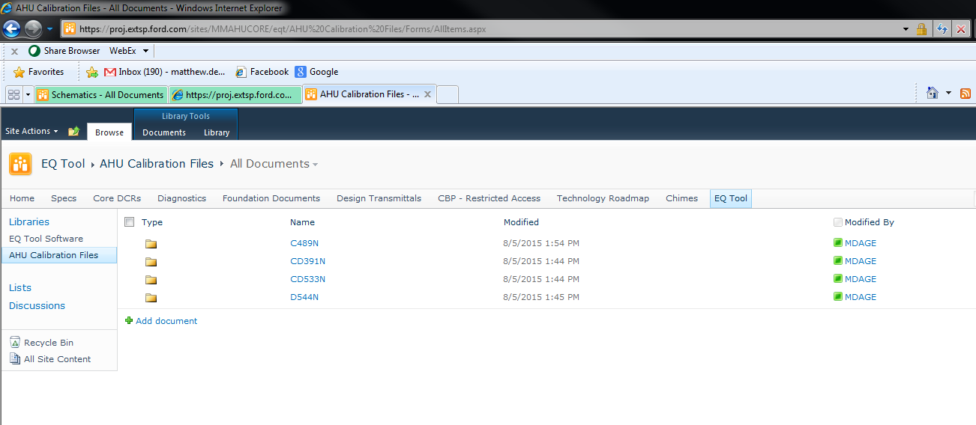

File structure is Program -> MY - > Milestone - > Speaker system - > EQ

1. Send email to AHU D&R that EQ file is ready to be released into IVS.

Chimes Engineers

1. Create Chimes file and save with descriptive name on computer.
2. Create temporary vbf file.  
   



1. Request secondary bootloader for AHU from AHU D&R.
2. Read F10A DID to see what current EQ+Chimes file is in radio (for post-VP builds).

Download from cross-supplier core sharepoint in appropriate folder  
File structure is Program -> MY - > Milestone - > Speaker system - > EQ+Chimes Merged vbf

1. Flash temporary vbf into AHU using DET tool and validate that the car measures the same as it did while live tuning. SWDL file order is secondary bootloader and Chimes vbf only.   
   
2. Flash EQ+Chimes merged vbf back into AHU using DET tool. If it’s a VP vehicle, flash flat EQ+Chimes merged vbf.
3. Upload to cross-supplier core sharepoint in appropriate folder



File structure is Program -> MY - > Milestone - > Speaker system - > Chimes

1. Send email to AHU D&R that Chimes file is ready to be released into IVS.

D&R Engineers

1. Send secondary bootloader to acoustics and chimes engineers.

After receiving emails from acoustics and chimes engineers that they’re projects are on the cross-supplier core sharepoint, download both files to computer.   
File structure is Program -> MY - > Milestone - > Speaker system - > EQ  
File structure is Program -> MY - > Milestone - > Speaker system - > Chimes

1. Select Open Project. Open EQ file.

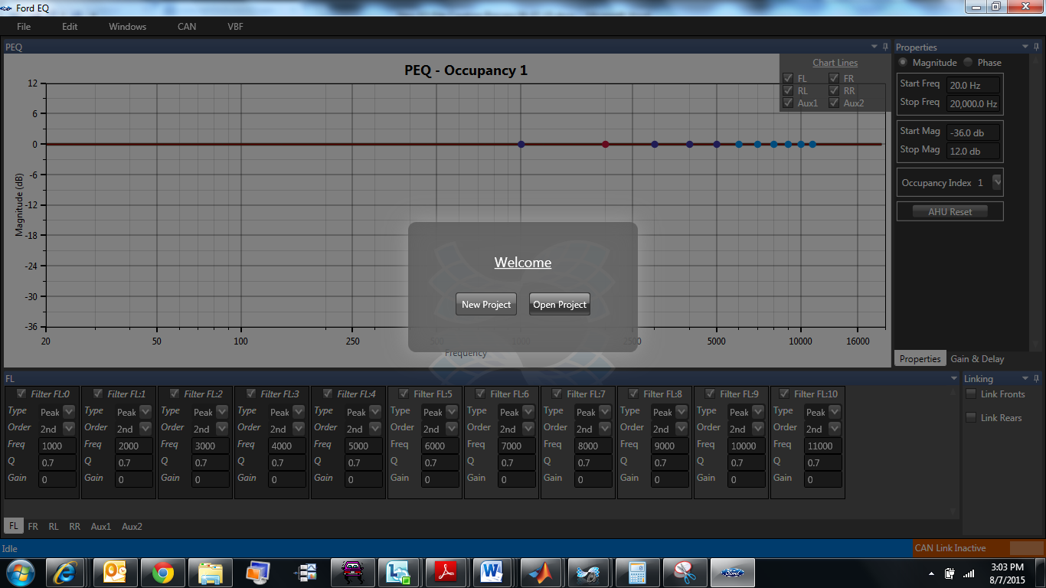

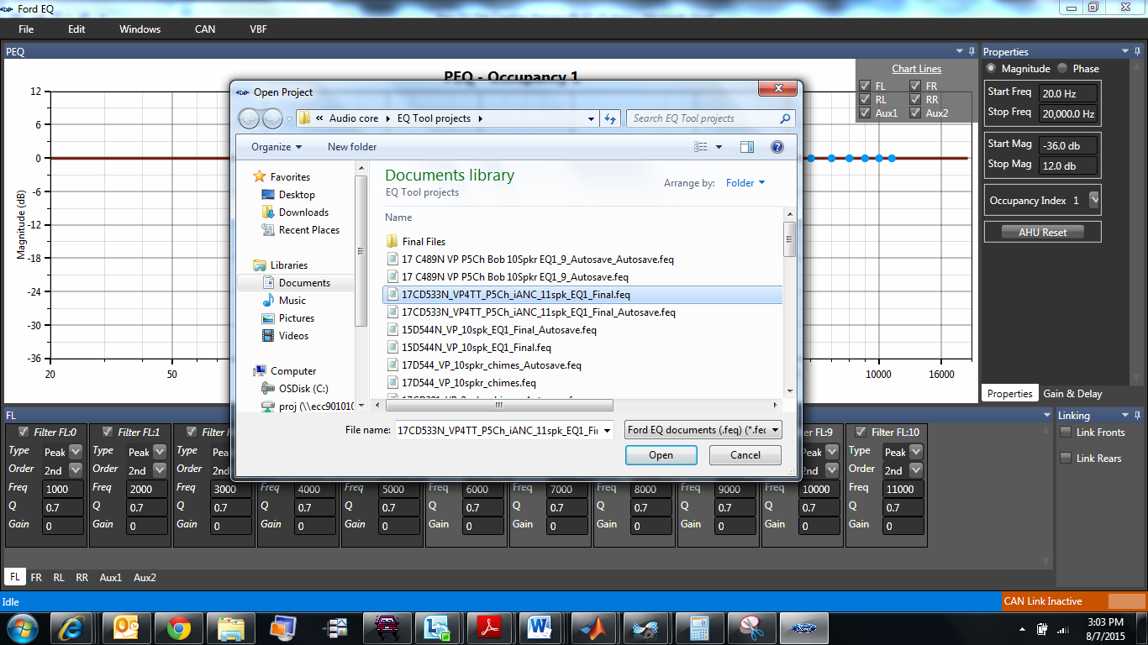

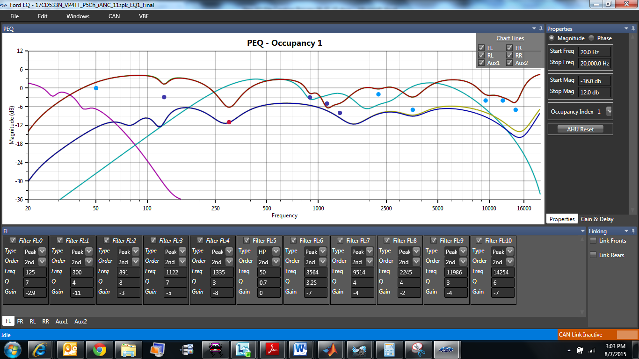

1. Select File - > Import Chimes. Open Chimes file.   
   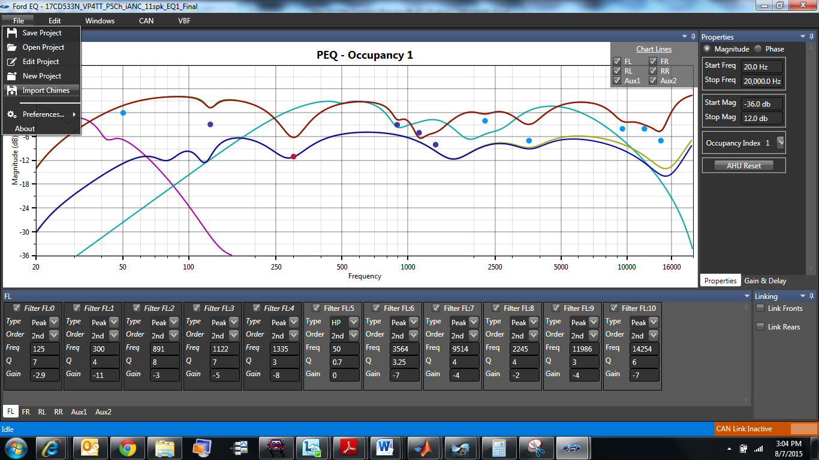

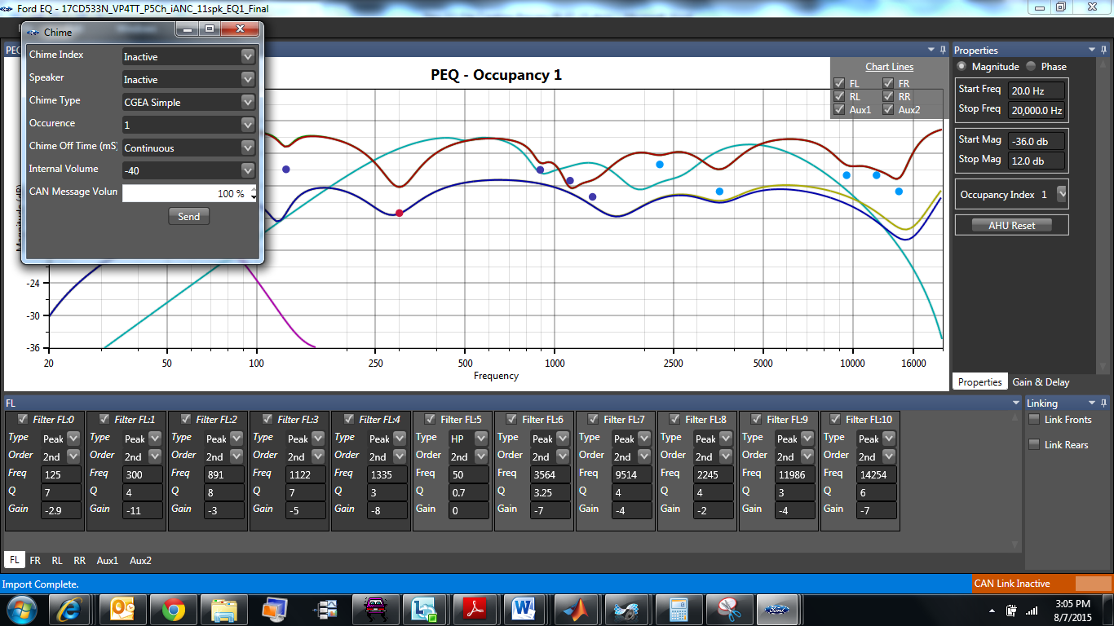

Chimes window will open to indicate file has been imported.

1. Create vbf file with official part number.  
   



1. Upload to cross-supplier core sharepoint in appropriate folder



File structure is Program -> MY - > Milestone - > Speaker system - > EQ+Chimes Merged vbf

1. Send email to IVS engineer with link to appropriate folder on cross-supplier core sharepoint to upload official file to IVS.